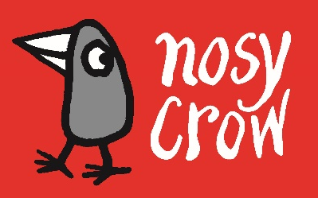
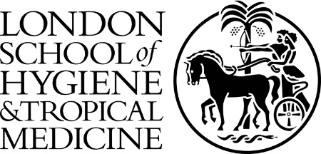

PRESS RELEASE

Embargoed for release: Monday 6th April at 1300

RELEASED TODAY: FREE INFORMATION BOOK EXPLAINING THE CORONAVIRUS TO CHILDREN, ILLUSTRATED BY GRUFFALO ILLUSTRATOR

Axel Scheffler has illustrated a digital book for primary school age children, free for anyone to read on screen or print out, about the coronavirus and the measures taken to control it. Published by award-winning independent children’s book publisher, Nosy Crow, and written by staff within the publishing company, the book has had expert input: Professor Graham Medley of the London School of Hygiene & Tropical Medicine acted as a consultant, and the company also had advice from two head teachers and a child psychologist.

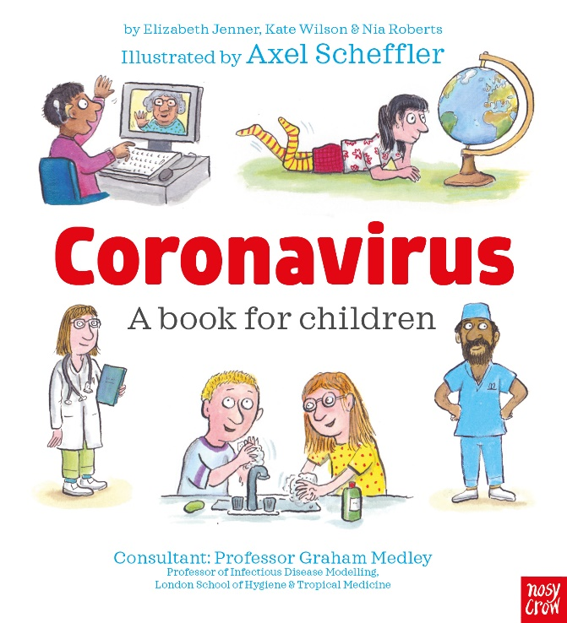
The book answers key questions in simple language appropriate for 5 to 9 year olds:

- What is the coronavirus?
- How do you catch the coronavirus?
- What happens if you catch the coronavirus?
- Why are people worried about catching the coronavirus?
- Is there a cure for the coronavirus?
- Why are some places we normally go to closed?
- What can I do to help?
- What’s going to happen next?

Nosy Crow wants to make sure that this book is accessible to every child and family and so the book is offered totally free of charge to anyone who wants to read it. However, the company suggests, at the back of the book, that families might make a donation to help our health service if they find the book useful: https://www.nhscharitiestogether.co.uk/.

Kate Wilson, Managing Director of Nosy Crow, said:

“We were very aware that many parents and carers are struggling to explain the current extraordinary situation to children, many of whom are frightened and confused. We thought that the best thing we could do would be to use our skills to produce a free book to explain and, where possible, reassure children. We asked Axel, whose work is so familiar and so loved, to illustrate it. He was happy to do it, and did it extraordinarily quickly. Meanwhile, having heard Professor Medley interviewed by the BBC, we looked him up and wrote to him, and despite his huge workload, he reviewed the book over a weekend, and we were able to incorporate his suggestions, together with those of two head teachers and a child psychologist, into the final version of the book. We hope it helps answer difficult questions in difficult times.”

Axel Scheffler, illustrator of The Gruffalo, said:

“I asked myself what I could do as an children’s illustrator to inform, as well as entertain, my readers here and abroad. So I was glad when my publisher, Nosy Crow, asked me to illustrate this question-and-answer book about the coronavirus. I think it is extremely important for children and families to have access to good and reliable information in this unprecedented crisis, and I hope that the popularity of the books I've done with Julia Donaldson will ensure that this digital book will reach many children who are now slightly older, but might still remember our picture books.”

Professor Graham Medley, Professor of Infectious Disease Modelling at the London School of Hygiene & Tropical Medicine, said:

“This pandemic is changing children’s lives across the globe and will have a lasting impact on us all. Helping children understand what is going on is an important step in helping them cope and making them part of the story - this is something that we are all going through, not something being done to them. This book puts children IN the picture rather just watching it happen, and in a way that makes the scary parts easier to cope with.”

You can download a copy of the book here.

Notes for Editors

A fixed format eBook will be available for free download from all eBook retailers and pre-orders are open now.

ABOUT NOSY CROW
Nosy Crow is a multi-award-winning publisher of child-focused, parent-friendly children’s books and eBooks for ages 0 – 14. It began publishing in 2011 and has won the Independent Publishers Guild’s Children’s Publisher of the Year Award three times. It was named Children’s Publisher of the Year at the British Book Awards in April 2017 and in April 2019, and in 2016 was awarded the Independent Publishers Guild Independent Publisher of the Year. Other prizes include a Queen’s Award for Enterprise – International Trade, The Stationers’ Company Innovation Excellence Award, The Nectar Business Small Business of the Year Award, The Growing Business Awards Young Company of the Year Award and many others for both individual books and for its marketing and international sales. Nosy Crow is already the 12th biggest children's book publisher in the UK, based on Nielsen-tracked sales to consumers.
www.nosycrow.com

ABOUT THE LONDON SCHOOL OF HYGIENE & TROPICAL MEDICINE
The London School of Hygiene & Tropical Medicine (LSHTM) is a world-leading centre for research, postgraduate studies and continuing education in public and global health. LSHTM has a strong international presence with over 3,000 staff and 4,000 students working in the UK and countries around the world, and an annual research income of £180 million. LSHTM is one of the highest-rated research institutions in the UK, is partnered with two MRC University Units in The Gambia and Uganda, and was named University of the Year in the Times Higher Education Awards 2016. Our mission is to improve health and health equity in the UK and worldwide; working in partnership to achieve excellence in public and global health research, education and translation of knowledge into policy and practice.
www.lshtm.ac.uk

ABOUT AXEL SCHEFFLER
Axel Scheffler is an award-winning, internationally-acclaimed illustrator of some of the most well-loved children’s books. His books have been published in many languages and his work has been exhibited all around the world. Axel is best known for his partnership with Julia Donaldson, on books including Room on the Broom and The Gruffalo. For Nosy Crow, Axel has illustrated a number of other highly successful titles, including the Pip and Posy series, The Grunts and the bestselling Flip Flap series. Axel lives in London with his partner and daughter.
Kate Wilson and Axel Scheffler are both available for interview/comment.

For more information please contact Rebecca Mason t: 07902430356 e: rebecca@nosycrow.com

